L02_Emmanuel_Igwilo_ITAI_1371.ipynb - Colab https://colab.research.google.com/drive/1_1D28ZJWETtul_M9xOsb9t...

Group 2
ITAI 1371 - Intro to Machine Learning
Emmanuel, Neha, Rida, Jun Fu

Module 2 Lab Exercise: Tools Used in Machine 
Learning
1
# Import libraries with standard aliases
2
import pandas as pd
3
import numpy as np
4
import matplotlib.pyplot as plt
5
from sklearn import datasets
6
import warnings
7
warnings.filterwarnings('ignore') # Hide warning messages for cleaner output 8
9
print(" All libraries imported successfully!")
10
print(f"Pandas version: {pd.__version__}")
print(f"NumPy version: {np.__version__}")
11
All libraries imported successfully!
Pandas version: 2.2.2
NumPy version: 2.0.2
 Part 2: Loading and Exploring Your First Dataset
1
# Load a simple dataset (Iris flowers - a classic beginner dataset) 2
from sklearn.datasets import load_iris
3
4
# Load the data
5
iris = load_iris()
6
print("Dataset loaded successfully!")
7
print(f"Dataset shape: {iris.data.shape}")
8
print(f"Features: {iris.feature_names}")
9
print(f"Target classes: {iris.target_names}")
Dataset loaded successfully!
Dataset shape: (150, 4)
Features: ['sepal length (cm)', 'sepal width (cm)', 'petal length (cm)', 'petal width Target classes: ['setosa' 'versicolor' 'virginica']
1
# Convert to pandas DataFrame for easier handling 2
df = pd.DataFrame(iris.data, columns=iris.feature_names) 3
df['species'] = iris.target_names[iris.target] 4
5
# Display first few rows
6
print("First 5 rows of our dataset:")
7
print(df.head())
8
1 of 6 9/25/2025, 2:41 PM
L02_Emmanuel_Igwilo_ITAI_1371.ipynb - Colab https://colab.research.google.com/drive/1_1D28ZJWETtul_M9xOsb9t... 8
9
10
print("\nDataset info:") print(df.info())
First 5 rows of our dataset:
sepal length (cm) sepal width (cm) petal length (cm) petal width (cm) \ 0 5.1 3.5 1.4 0.2 1 4.9 3.0 1.4 0.2 2 4.7 3.2 1.3 0.2 3 4.6 3.1 1.5 0.2 4 5.0 3.6 1.4 0.2
species
0 setosa
1 setosa
2 setosa
3 setosa
4 setosa
Dataset info:
<class 'pandas.core.frame.DataFrame'>
RangeIndex: 150 entries, 0 to 149
Data columns (total 5 columns):
# Column Non-Null Count Dtype
--- ------ -------------- -----
0 sepal length (cm) 150 non-null float64
1 sepal width (cm) 150 non-null float64
2 petal length (cm) 150 non-null float64
3 petal width (cm) 150 non-null float64
4 species 150 non-null object
dtypes: float64(4), object(1)
memory usage: 6.0+ KB
None
 Part 3: Creating Your First Visualization
1
# Create a simple scatter plot
2
plt.figure(figsize=(10, 6))
3
4
# Plot sepal length vs sepal width, colored by species
5
species_colors = {'setosa': 'red', 'versicolor': 'blue', 'virginica': 'green' 6
7
for species in df['species'].unique():
8
species_data = df[df['species'] == species]
9
plt.scatter(species_data['sepal length (cm)'],
10
species_data['sepal width (cm)'],
11
c=species_colors[species],
label=species,
12
alpha=0.7)
13
14
plt.xlabel('Sepal Length (cm)')
15
2 of 6 9/25/2025, 2:41 PM
L02_Emmanuel_Igwilo_ITAI_1371.ipynb - Colab https://colab.research.google.com/drive/1_1D28ZJWETtul_M9xOsb9t...
16
plt.ylabel('Sepal Width (cm)')
17
plt.title('Iris Dataset: Sepal Length vs Sepal Width') 18
plt.legend()
19
plt.grid(True, alpha=0.3)
20
plt.show()
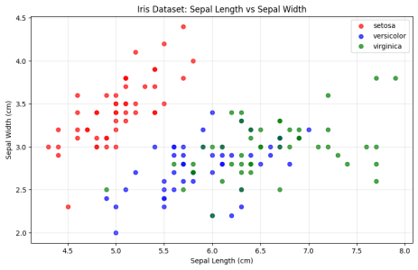 Part 4: Practice with Basic Data Operations
1 2 3 4 5 6 7 8 9 10 11
# Basic statistical analysis
print("Basic Statistics for Iris Dataset:") print("=" * 40)
# Calculate mean values for each species species_means = df.groupby('species').mean() print("\nMean values by species:") print(species_means)
# Count samples per species
species_counts = df['species'].value_counts()
3 of 6 9/25/2025, 2:41 PM
L02_Emmanuel_Igwilo_ITAI_1371.ipynb - Colab https://colab.research.google.com/drive/1_1D28ZJWETtul_M9xOsb9t...
11 12 13
species_counts = df['species'].value_counts() print("\nSamples per species:")
print(species_counts)
Basic Statistics for Iris Dataset:
========================================
Mean values by species:
sepal length (cm) sepal width (cm) petal length (cm) \ species
setosa 5.006 3.428 1.462 versicolor 5.936 2.770 4.260 virginica 6.588 2.974 5.552
petal width (cm)
species
setosa 0.246
versicolor 1.326
virginica 2.026
Samples per species:
species
setosa 50
versicolor 50
virginica 50
Name: count, dtype: int64
1
# Calculate the mean and standard deviation of sepal length
2
3
sepal_lengths = df['sepal length (cm)']
4
5
mean_sepal_length = np.mean(sepal_lengths)
6
std_sepal_length = np.std(sepal_lengths)
7
8
print(f"Mean sepal length: {mean_sepal_length:.2f} cm")
9
print(f"Standard deviation: {std_sepal_length:.2f} cm")
10
11
# Verification (don't modify)
assert isinstance(mean_sepal_length, (float, np.floating)), "Mean should be a numb
12
13
assert isinstance(std_sepal_length, (float, np.floating)), "Std should be a number
Mean sepal length: 5.84 cm Standard deviation: 0.83 cm
1 2 3 4 5 6 7 8
# Task 2: Create a simple bar chart showing species counts species_counts = df['species'].value_counts()
plt.figure(figsize=(8, 5))
plt.bar(species_counts.index, species_counts.values, color=['red', 'blue', plt.title('Number of Samples per Species')
plt.xlabel('Species')
plt.ylabel('Count')
4 of 6 9/25/2025, 2:41 PM
L02_Emmanuel_Igwilo_ITAI_1371.ipynb - Colab https://colab.research.google.com/drive/1_1D28ZJWETtul_M9xOsb9t...
8 9 10 11
plt.ylabel('Count')
plt.show()
print(f"Species distribution: {dict(species_counts)}")
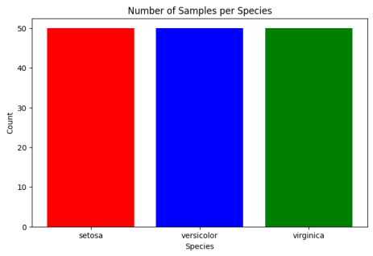Species distribution: {'setosa': np.int64(50), 'versicolor': np.int64(50), 'virginica':
Analysis and Re�ection
My Observations About the Iris Dataset
Dataset Overview:
• Number of samples: 150
• Number of features: 4
• Number of classes: 3
Key Findings from the Visualization:
���Setosa �owers form a clearly separated cluster with smaller sepal length and larger sepal width compared to the others
���Versicolor and Virginica have overlapping regions, making them harder to
distinguish with just sepal length vs. sepal width.
5 of 6 9/25/2025, 2:41 PM
L02_Emmanuel_Igwilo_ITAI_1371.ipynb - Colab https://colab.research.google.com/drive/1_1D28ZJWETtul_M9xOsb9t...
���Sepal length tends to increase across species
Questions for Further Investigation:
• Can petal measurements provide be�er separation between the classes than sepal measurements?
• Which features are most important for accurately classifying the species?
Re�ection: I learned that libraries like pandas, NumPy, and matplotlib make it much
easier to organize, analyze, and visualize data. Using these tools, I was able to quickly load the Iris dataset, explore its features, and create visualizations that reveal pa�erns between species.

